MULJIBHAI MEHTA INTERNATIONAL SCHOOL
A.Y. 2021-2022

PRE- PRIMARY ONLINE ADMISSION
DEMO – 2
Date: 23.12.2020
Issues related to the process are noted here.
- Link to open particular student form (for verification of documents) provide token number as a link in clerk login.
- Only verified students should appear to principal ma’am (hide others non-verified) (Link to open particular student form)
- Design of the form is not up to the expectation (refer picture – 2). NOT POSSIBLE
- Clear fields are not working properly when refresh page the old value remains in the textbox and page is not allowing editing.
- Errors displaying are improper. Refer picture – 1.
- Press tab to add another entry is missing for siblings refer picture – 4. To rajesh sir
- When selected admission for Twins (token generation form) all other details remain same for twin like date of birth father name, email id etc., only name of the child should be blank to fill.
- Design of admission form section wise to page wise as written in the initial requirements. (Refer PPT slide no – 12 to 20). To rajesh sir
- Declaration part Father/Mother dropdown list is missing. To rajesh sir
- Not possible to check accountant’s part as Principal Ma’am approval part is giving error and both are interconnected. I check it’s done
- Pin Code accepting alphabets. DONE
- Admin verification - "token no" list should be displayed --> by clicking on the token number the form should open, (option to download the uploaded files) they will update "verified".

Reference pictures –
- Picture – 1
Error should be displayed here as – “please enter Aadhar Card number.”
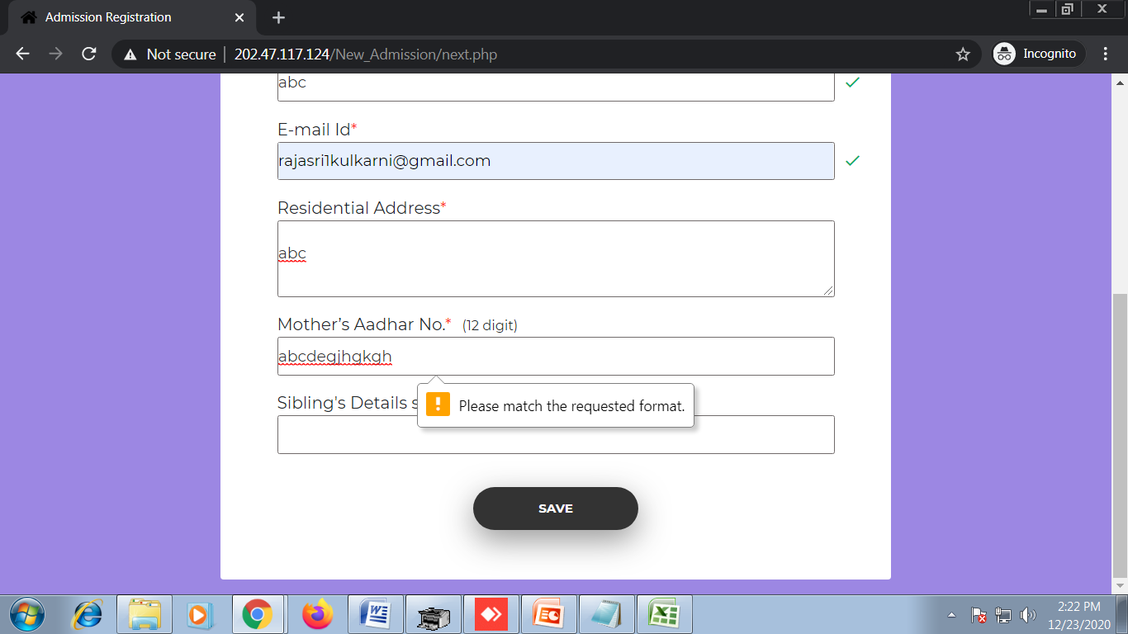
- Picture – 2
The input is of any field here is a single value where as the width of each box is more than required.
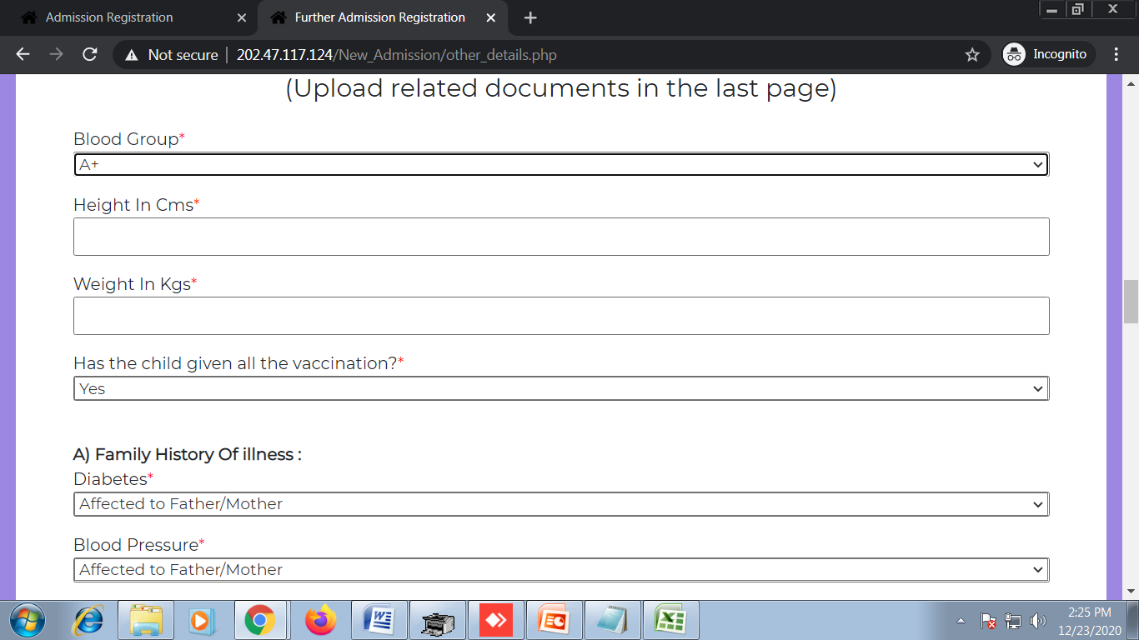

- Picture – 3 mismatch of fields in design.
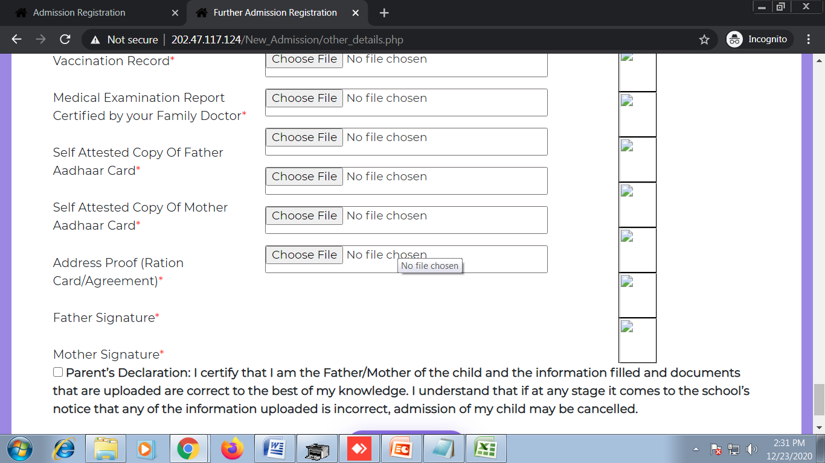

- Picture – 4
Not possible to enter next value i.e. 3rd value (More than 2 siblings?)
